18 Apr 2025 Good Friday Service Songs
Welcome
Bible Reading: Mark 15:25-39
Song 1: Hymn of the Savior
Song 2: The Goodness of Jesus
Bible Reading 2: 1 Pet 2:22-25
Song 3: Power of the Cross
Sermon
Closing: Christ our hope in life and death

Hymn of the Saviour: Emu Music (C)
Keys intro
[Intro]
F Am C2 C2

[Verse 1]
Am F
From the chaos of darkness
C G
Your word shaped the earth
Am F C
In your image a people made
Am F
But we traded perfection
C G
The truth for a lie
Am F C
And your glory was veiled in shame

[Verse 2]
F C
But a promise made
G Am
A blessing you gave
F C G
To a people of your name
F C
For this broken world
Em Am
A saviour foretold
F G
To bear all our grief and pain

F Am C C x2
[Verse 3] Build Up
Am F
When the heavenly saviour
C G
Descended his throne
Am F C
All my sin on his shoulders laid
Am F
And to win our redemption
C G
He suffered and died
Am F C
For the sake of my guilt and shame

[Verse 4]
F C
Oh the price he paid
G Am
In taking my place
F C G
so that death was overcome
F C
For the king of love
Em Am
Burst forth from the grave
F G
Proclaiming the victory won

F Am C C x2

[Verse 5] (Soft)
Am F
At the end of the ages
C G
The world passed away
Am F C
I will gaze on my saviour's face
Am F
When my heart is perfected
C G
Free from my sin
Am F C (build)
I will rest in your glorious grace
Build to top
[Verse 6]
F C
For the song we raise
G Am
The works of our hands
F C G
Are in service of the king
F C
When a thousand tounges
Em Am
Cry "Glory to God"
F G F
Forever his praise we'll sing
F C
For the song we raise
G Am
The works of our hands
F C G
Are in service of the king
F C
When a thousand tounges
Em Am
Cry "Glory to God"
F G Am
Forever his praise we'll sing
F G F
Forever his praise we'll sing
Am C C
F Am C End

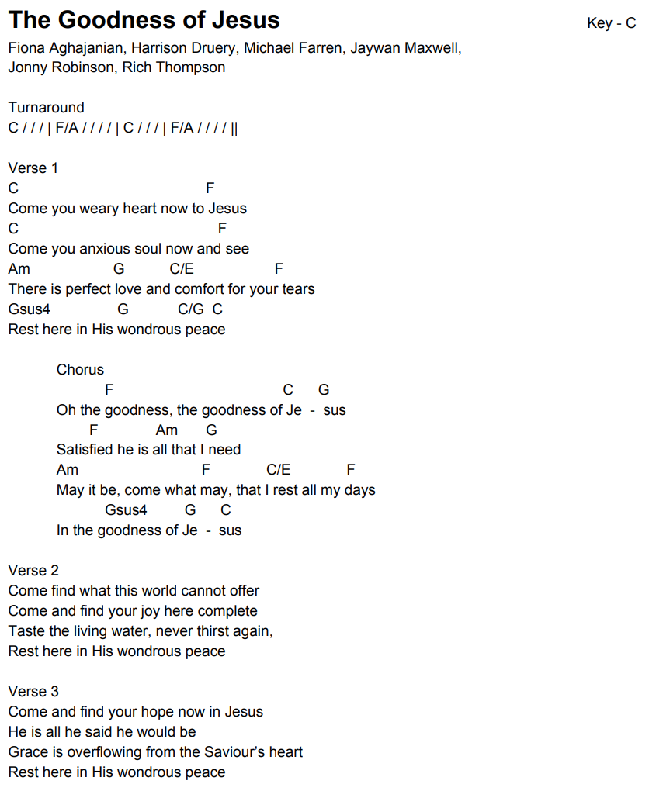
Power of the cross (C)
[Intro]
Am G/B C Em F x2

[Verse]

Am G/B C
Oh, to see the dawn
C Dm C/E
Of the darkest day
F C/E Dm C G/B
Christ on the road to Calvary.
Am G/B C
Tried by sinful men,
C Dm C/E
Torn and beaten, then
F C/E G
Nailed to a cross of wood.

[Chorus]
(Em) F G C
This, the pow'r of the cross:
(Em) F G C
Christ became sin for us;
(Em) F F#dim G
Took the blame, bore the wrath—
G/B Am G Am G/B C Em F
We stand forgiven at the cross.

[Verse]
Am G/B C
Oh, to see the pain
C Dm C/E
Written on Your face,
F C/E Dm C G/B
Bearing the awesome weight of sin.
Am G/B C
Ev'ry bitter thought,
C Dm C/E
Ev'ry evil deed
F C/E G
Crowning Your bloodstained brow.

SOFT
Am G/B C
Now the daylight flees;
C Dm C/E
Now the ground beneath
F C/E Dm C G/B
Quakes as its Maker bows His head.
Am G/B C
Curtain torn in two,
C Dm C/E
Dead are raised to life;
F C/E G G/A G/B
"Finished!" the vict'ry cry.

Chorus
(Em) F G C
This, the pow'r of the cross:
(Em) F G C
Christ became sin for us;
(Em) F F#dim G
Took the blame, bore the wrath—
G/B Am G Am G/B C Em F x2
We stand forgiven at the cross.

Am G/B C
Oh, to see my name
C Dm C/E
Written in the wounds,
F C/E Dm C G/B
For through Your suffering I am free.
Am G/B C
Death is crushed to death;
C Dm C/E
Life is mine to live,
F C/E G
Won through Your selfless love.

[Final chorus]
(Em) F G C
This, the pow'r of the cross:
(Em) F G C
Son of God—slain for us.
(Em) F F#dim G
What a love! What a cost!
G/B Am G Am G/B C Em F
We stand forgiven at the cross.
Christ our Hope in Life and Death

[Intro]
E Esus E x2

[Verse 1]
E Esus E
What is our hope in life and death?
Esus E C#m B
Christ alone, Christ alone.
E B/D# C#m
What is our only confidence?
A E/B B E
That our souls to Him belong.
G#m C#m
Who holds our days within His hand?
F#m7 E/G# A
What comes, apart from His command?
E B/D# C#m
And what will keep us to the end?
A E/B B E Esus E
The love of Christ, in which we stand.

[Chorus]
C#m (A) E
O sing hallelujah!
B/D# C#m
Our hope springs eternal;
E/G# A E/G#
O sing hallelujah!
A E/G# B A
Now and ever we confess
C#m7 B E Esus E
Christ our hope in life and death.

[Verse 2]
E Esus E
What truth can calm the troubled soul?
Esus E C#m B
God is good, God is good.
E B/D# C#m
Where is His grace and goodness known?
A E/B B E
In our great Redeemer’s blood.
G#m C#m
Who holds our faith when fears arise?
F#m7 E/G# A
Who stands above the stormy trial?
E B/D# C#m
Who sends the waves that bring us nigh
A E/B B E
Unto the shore, the rock of Christ?

[Chorus]
C#m A E
O sing hallelujah!
B/D# C#m
Our hope springs eternal;
E/G# A E/G#
O sing hallelujah!
A E/G# B A
Now and ever we confess
C#m7 B E Esus E
Christ our hope in life and death.

E Esus E x2

[Verse 3]
E Esus E
Unto the grave, what will we sing?
Esus E C#m B
“Christ, He lives; Christ, He lives!”
E B/D# C#m
And what reward will heaven bring?
A E/B B E
Everlasting life with Him.
G#m C#m
There we will rise to meet the Lord,
F#m7 E/G# A
Then sin and death will be destroyed,
E/B G#/C C#m
And we will feast in endless joy,
A E/B B E (hold)
When Christ is ours forevermore.

[Final Chorus]
C#m A E
O sing hallelujah!
B/D# C#m
Our hope springs eternal;
E/G# A E/G#
O sing hallelujah!
A E/G# B A
Now and ever we confess
C#m7 B (E) C#m7
Christ our hope in life and death. (x2)

A E/B E/G# A
Now and ever we confess
C#m7 B/D# E
Christ our hope in life and death.

